Linux File Creation
Task:
- Create a directory called ""my_folder"", navigate into it, and create a file named ""my_file.txt"" with some text. Then, create another file named ""another_file.txt"" with some text. Concatenate the content of ""another_file.txt"" to ""my_file.txt"" and display the updated content. Finally, list all files and directories in the current directory.
Prerequisite:
AWS-Putty.
Step-by-Step Guide:
- Creating a folder:
- Create a single directory
mkdir my_folder

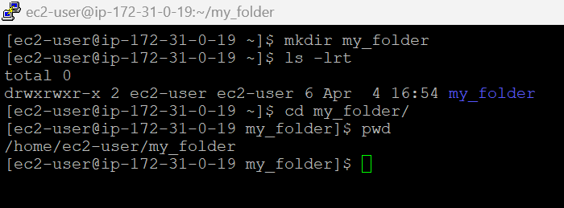

- Creating and Editing Files
- Creating and editing the files with the given text
echo "This is my_file." > my_file.txt
- We can also use vi to create a new file as below
vi another_file.txt

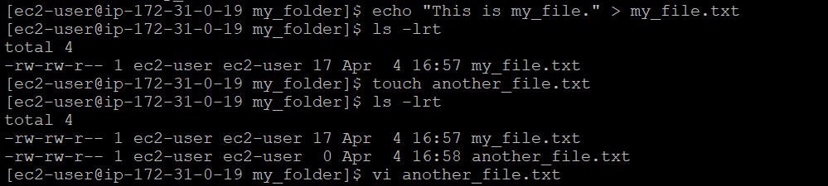
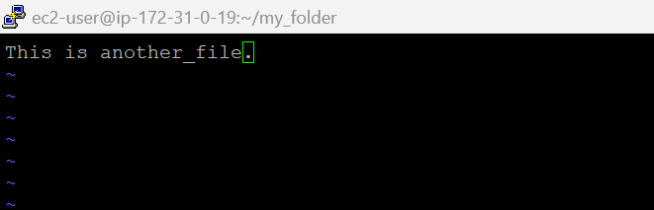
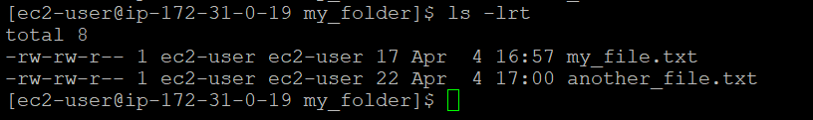
- Merging File Content and displaying content
- To concatenate the content of ""another_file.txt"" to ""my_file.txt""
>> means append (so it won’t overwrite anything).
cat another_file.txt >> my_file.txt
- To what’s inside my_file.txt now:
cat my_file.txt

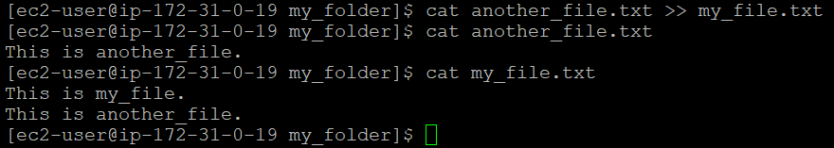

- Create 20 files with .txt extensions and rename the first 5 files to .yml extension and Print the latest created top 5 files among the total no of files".

- Creating & Renaming Files
- Now to create 20 empty files:
touch file{1..20}.txt
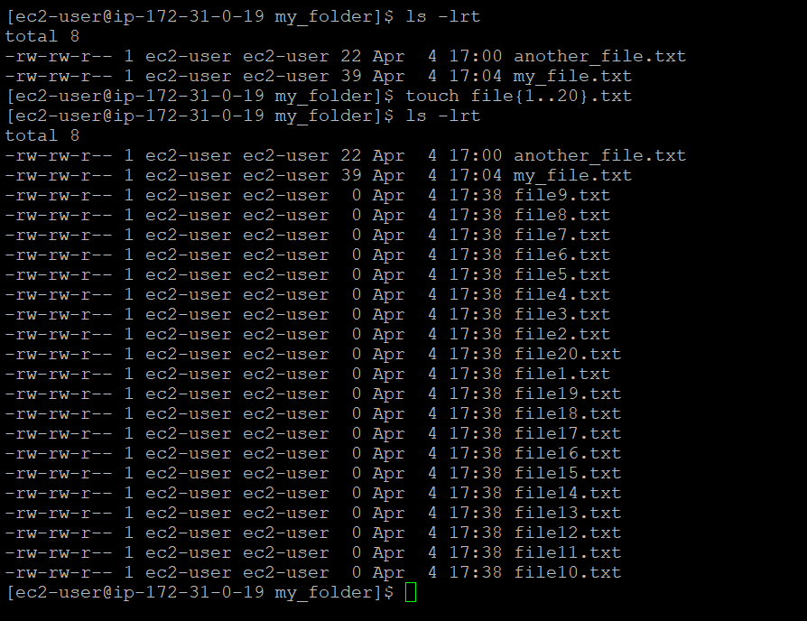

- To rename
for i in {1..5}; do mv file$i.txt file$i.yml; done
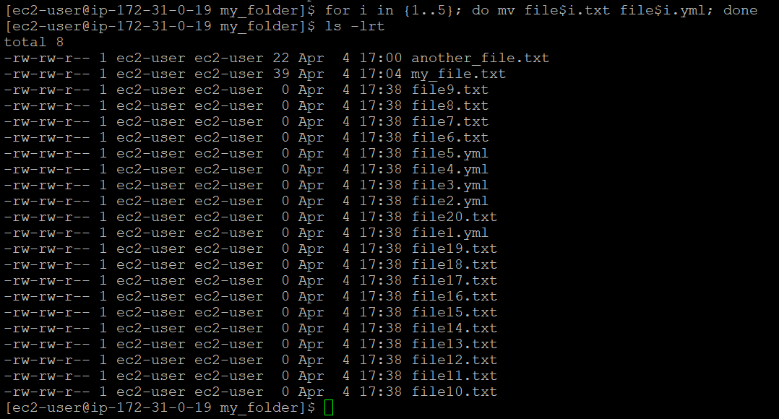

- Breakdown of that command:
for i in {1..5}
- This is a loop.
- It will run the loop 5 times, where i will take values from 1 to 5. So, i = 1, then 2, 3, 4, 5
do mv file$i.txt file$i.yml
- mv is the move/rename command.
In each loop: It renames file1.txt to file1.yml, Then file2.txt to file2.yml and so on till file5.txt to file5.yml
done
- Ends the loop.

- Finding Recent Files
- To see the latest 5 files
ls -lt | head -6
